**USER MANAGEMENT DOCUMENT**

| MULTIPLE USER MANAGEMENT DOCUMENT | 20-August-2021 | |
| --- | --- | --- |
| **User Management** | |  |

| **REVISION HISTORY** | | | |
| --- | --- | --- | --- |
| **REV** | **Description of Change** | **Author** | **Effective Date** |
| 1.0 | Creation of the Document | Dipali Laxman Nagtilak | 20-August-2021 |
| 1.1 | Reviewed By |  |  |
| 1.1 | Approved By |  |  |

**INDEX**

Introduction **3**

Purpose 3

About User Management 3

Prerequisite **3**

Basic Requirement 3

Screenshots 3

Repository 6

MySQL workbench setting for bulk import 6

Application Code 6

# Introduction

## Purpose

The purpose of the document is to describe the process of Importing Multiple Users to the database using a developed application.

## About User Management

Developed an application to be able to upload a spreadsheet of users and their information and to be able to import users to make changes easily.

# Prerequisite

## Basic Requirement

| **Sl. No.** | **Category** | **Software Title** |
| --- | --- | --- |
| **1** | Operating System | Windows Server 2012 or above |
| **2** | Platform/Language | .Net Core 2.2 ,C# , JSON, JQUERY |
| **3** | Database | My SQL |
| **4** | Web Server | IIS 7.0 or above |
| **5** | Components | Dapper ,EPPLUS,Serilog,FluentValidator |

## Screenshots

Admin users should login to HWC portal using their credential and after successful login admin dashboard will land.

If admin want to import the users to HWC portal then user will click on bottom right corner . And it will redirect to another application for import users using a predefined excel sheet.

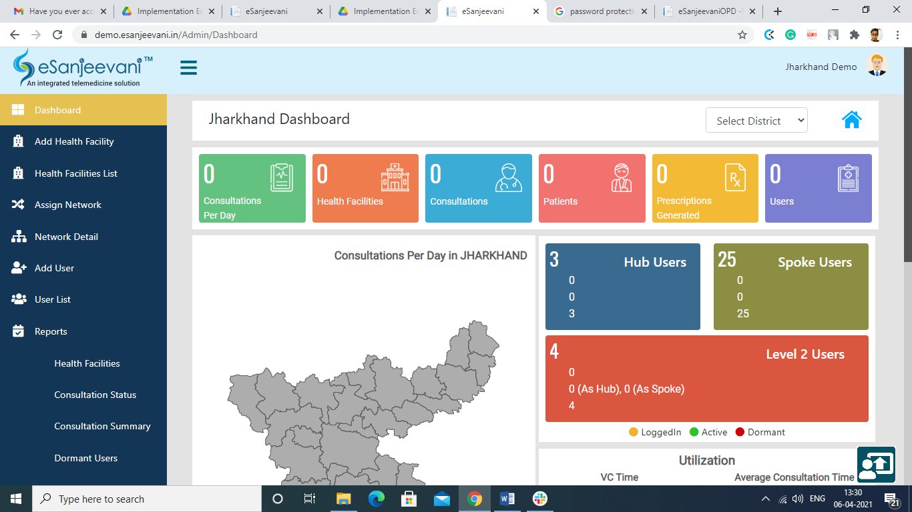

User will navigate to Bulk import on below screen

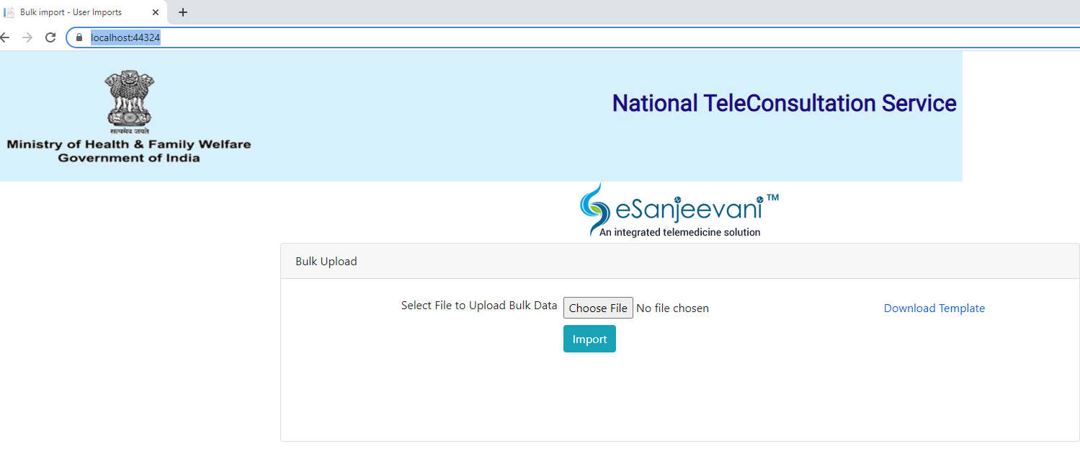

Click on “Download Template” and the user will get the template for the bulk import.Fill the data in the downloaded template.

Click on “Choose File”. Select the filled “UserTemplate.xlsx” file and click on the Import button.

Below screen will appear where successfully inserted data comes under “Sucess Data” and unsuccessful data comes under ”Error Data”

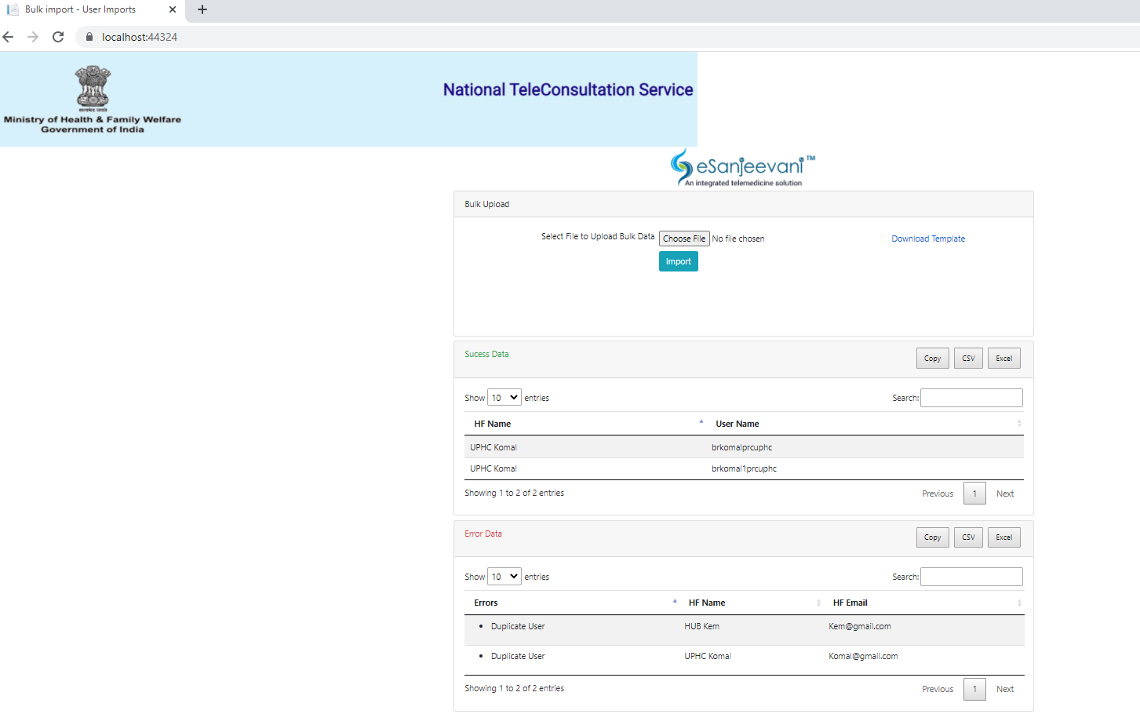

After inserting the data, the user has the facility to export the inserted and non inserted records in CSV,Excel and Copy to clipboard format.

## Repository

URL<https://github.com/Intelehealth/Registration_Module_Script>

## MySQL workbench setting for bulk import

eSanjeevani-Registration-Module SET GLOBAL local_infile = true;

By doing below steps on server side Administration-->Server--->Status and system variable--->system variable-->Local Infile-->true refer below image for above step

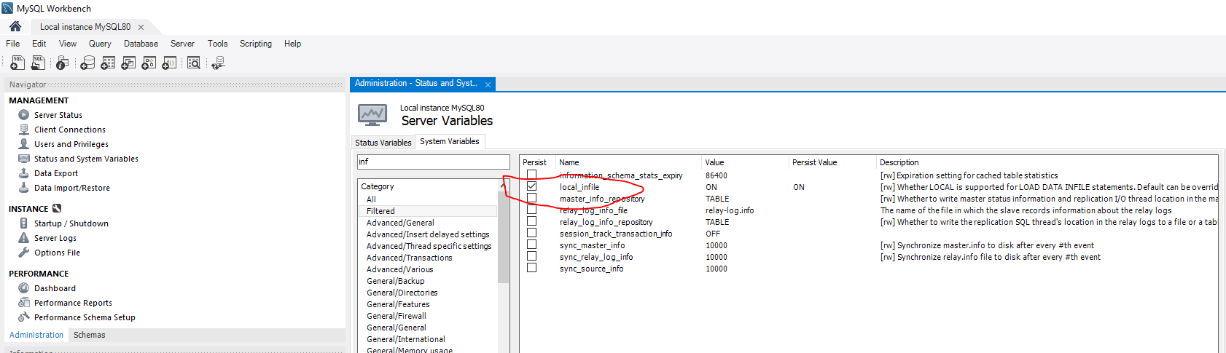

## 2.5 Application Code

Application code is divided into business,contract,domain,infrastructure,UserManagement(Web).

**2.5.1 Business**

1. In the business module we have defined validators and services.

**2.5.2** **Contract**

1. In the contract we have created interfaces for factory,Repository,User and Utility.

**2.5.3** **Domain**

1. In the domain we have created ViewModel for bulk import.
2. Defined all models.

**2.5.4 Infrastructure**

1. Defined Csv and Excel utility.
2. Created Mapping.
3. Created Repository.

**2.5.5 Web**

1. All controllers, models and views are present.

**2.6 Exception Handling and error logging**

1. We have created a user friendly and developer friendly screen to display the error.Below screen will appear in case of exception.

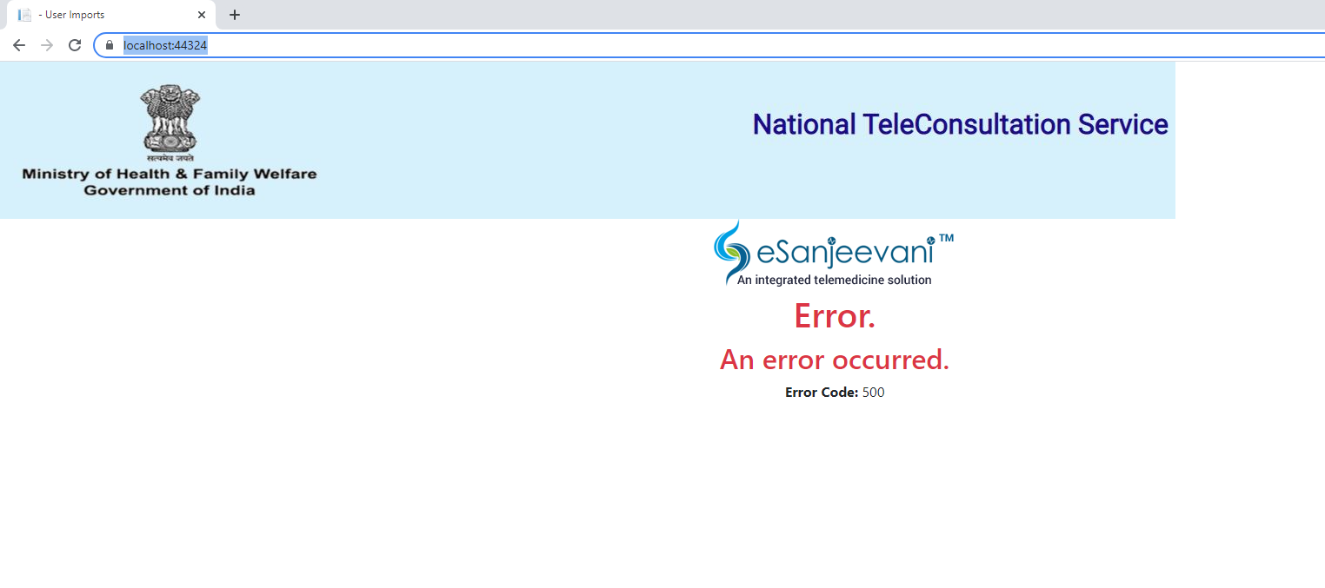

1. A Detailed log file has been maintained in UserManagement\UserManagement\Logs\Exception\log.txt. The log file will generate date wise. If you want to go in detail please refer below link
2. https://github.com/serilog/serilog-sinks-file
3. In case of data insertion we have maintained the csv log file in UserManagement\UserManagement\Logs\Csv folder. After 15 days the file will get deleted automatically.
4. Created CSV log file for the below model.
5. InsituteModel
6. LoginModel
7. MemberInstitutionModel
8. MembersSlotModel

**Please Note:**

1. **If the rows are empty, kindly delete the rows before uploading.**
2. **Don’t add the link in case of email id. It should be in plain text.**
3. **Don’t add any format for the excel column like date,time it should be plain text only.**
4. **Make sure you enter “Date of Birth DD-MM-YYYY” in the correct format e.g 05-02-2021.**
5. **If a user enters the wrong city then the application picks any right city from the respective District.**